ETHNIC Wear Celebrations 2019

To
Department of Higher Education
Ministry of Human Resource Development

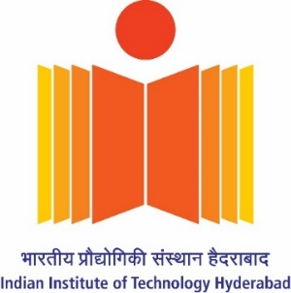

Submitted by

Indian Institute of Technology Hyderabad
Sangareddy, Kandi-502285
Telangana, India
https://www.iith.ac.in/

22nd November 2019

Ethnic Wear Celebrations 2019
Date: 22.11.2019 | Time: 09:40AM to 09:00PM
Participants: Students & Faculty of IITH

EBSB club at IIT Hyderabad came together to celebrate 22nd November, 2019 as Ethnic Day, organized under the Ek Bharat Shreshtha Bharat programme initiated by the MHRD, the purpose of the event was to honor and celebrate the vast and kaleidoscopic cultural diversity of India. This would be followed by various other competitions and events in coming days which would bring out the traditions and cultures of the different states of India.

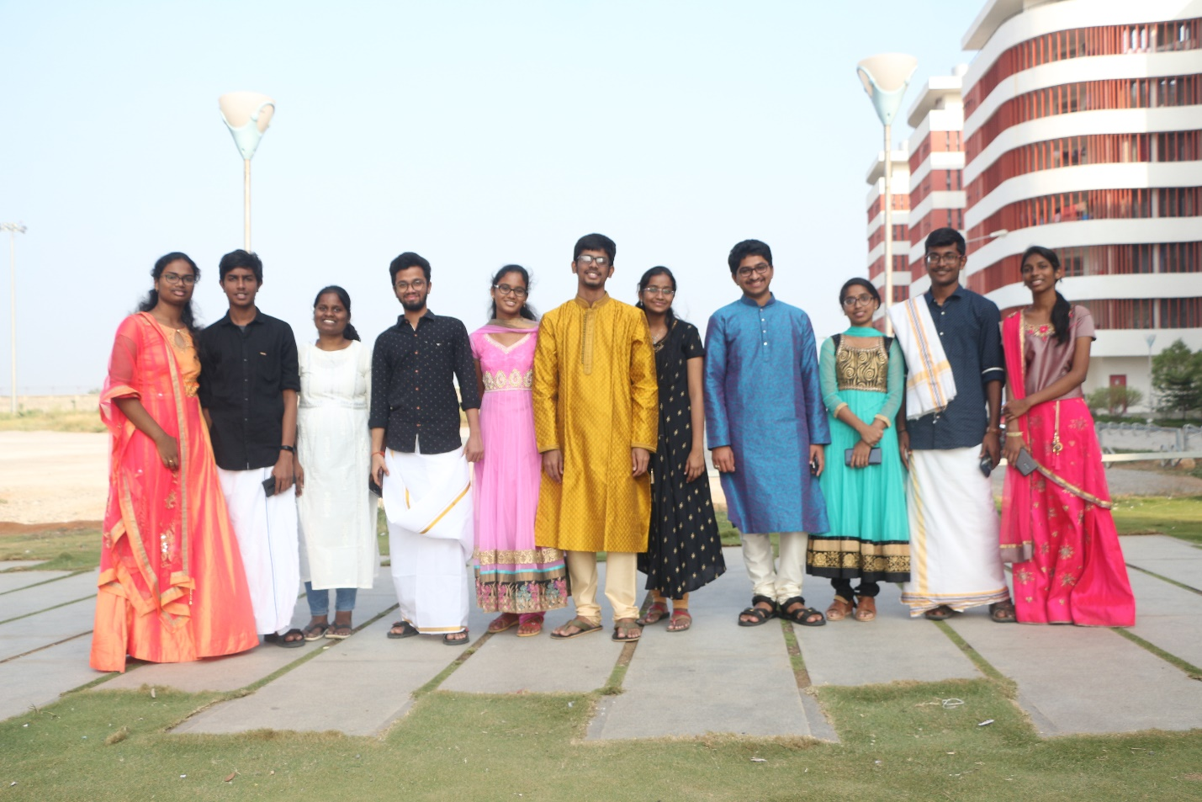

The students attended classes, dressed up in the traditional attires of their respective home states the entire day, it turned out to be a memorable day for all the students and a true success for the organizers. With all the states represented in full flourish in the classroom, the atmosphere was that of utmost respect for each-others’ cultures and for the unity blooming in the diversity of India.
students uploaded pictures of themselves in traditional attires on social media, many commendations poured in for the initiative from all over the country. It was simply a day for people to be proud of their ethnicity and display it in the form of there attires.
